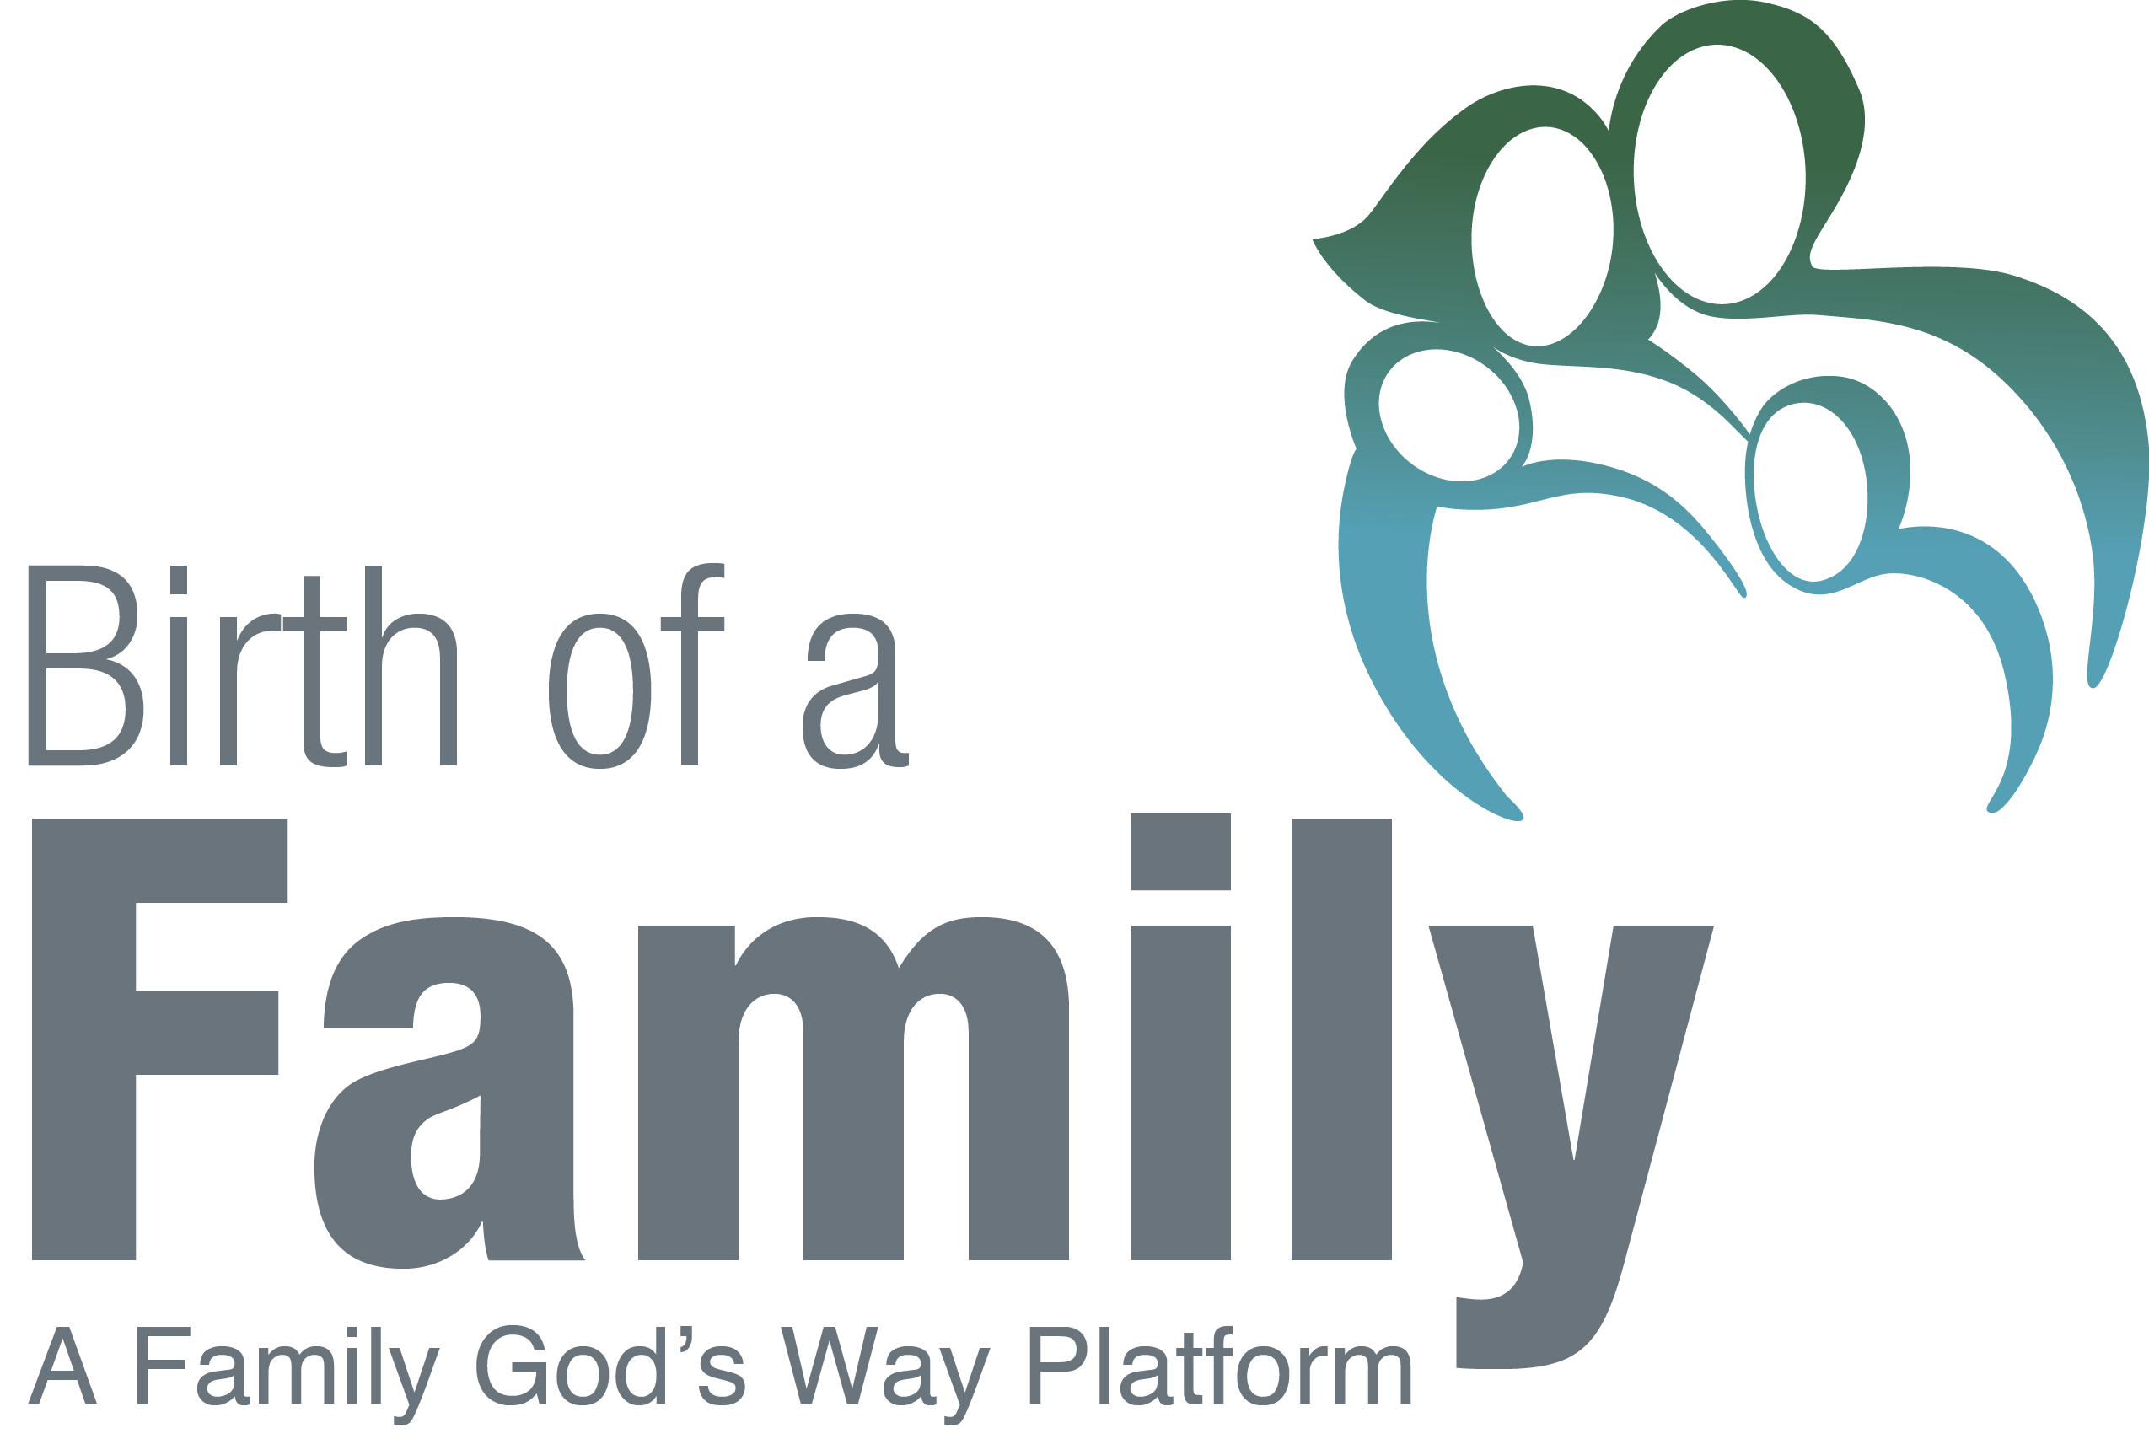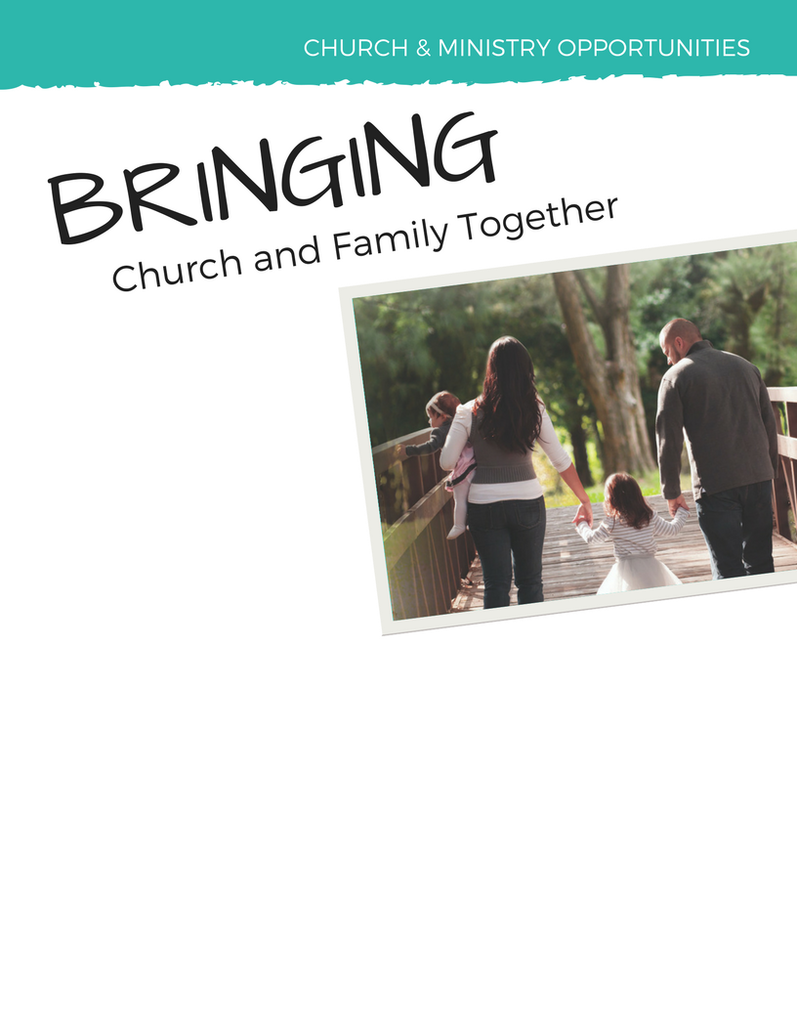

Birth of a Family is a great way for you to reach those truly in need by walking alongside them as they face many of life’s challenges.

Join Us!

[Insert information about training and/or group meeting times here.]

Ministry to the family is perhaps the most impactful yet time consuming pastoral ministry churches face today.

The Birth of a Family program offers a unique opportunity for the Church to participate in family ministry. We seek people to become trained Facilitators and mentors who accompany participants through the Birth of a Family discussions guides.

Through their participation as facilitators & mentors, the Body of Christ is enjoying powerful opportunities in the ministry of the Gospel such as:

* Engaging in ministry outside their own Church walls
* Serving their communities
* Helping others found and grow strong Biblical households
* Introducing Birth of a Family participants to new church homes